**HOME WORK JAVA – CSA0986**

1. **COMPILE TIME PROGRAM SUBRACTION BY BUFFER READER IN JAVA:**

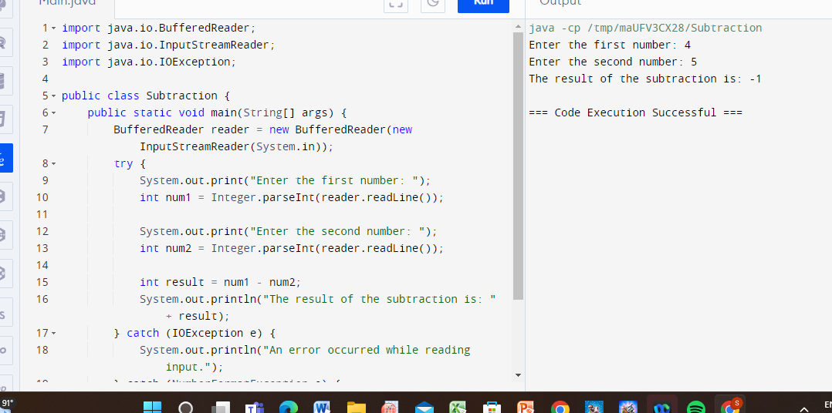

1. **COMPILE TIME PROGRAM SUBRACTION BY SCANNER CLASS IN JAVA:**

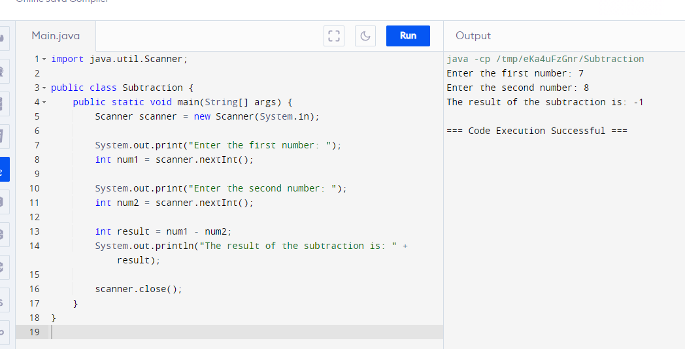

1. **COMPILE TIME PROGRAM MULTIPLICATION BY BUFFER READER IN JAVA:**

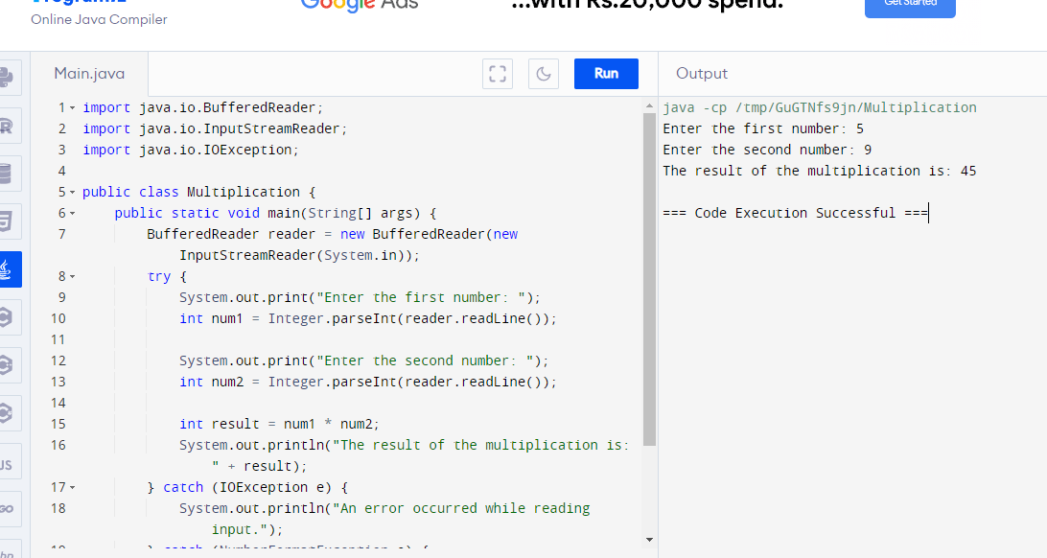

1. **COMPILE TIME PROGRAM MULTIPLICATION BY SCANNER CLASS IN JAVA:**

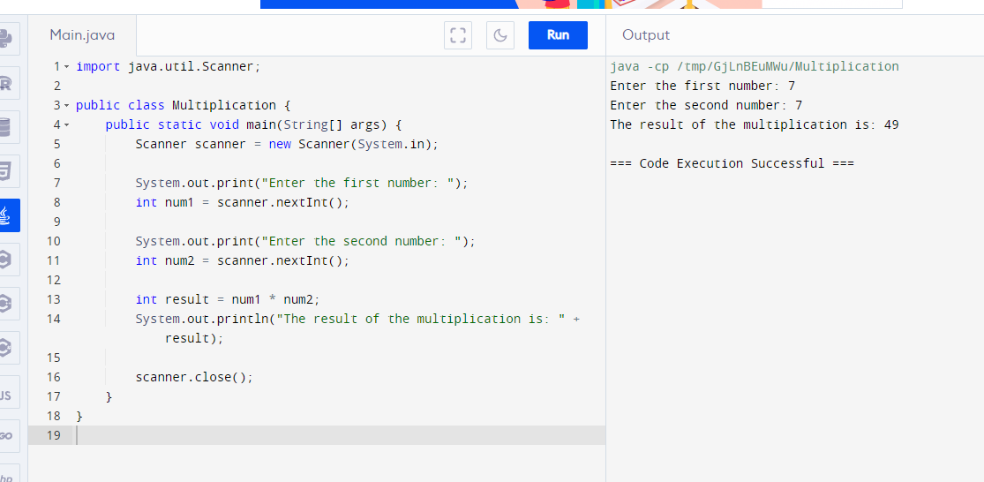

1. **COMPILE TIME PROGRAM FLOOR BY BUFFER READER IN JAVA:**

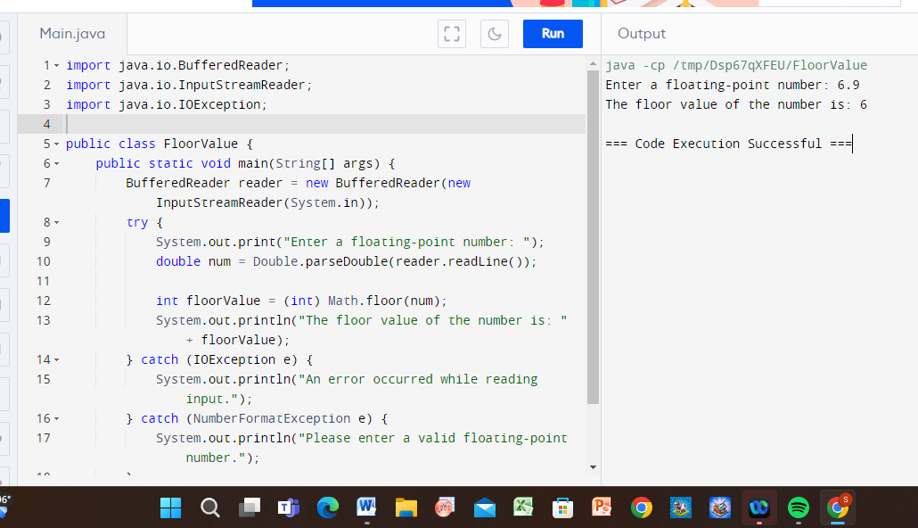

1. **COMPILE TIME PROGRAM FLOOR BY SCANNER READER IN JAVA:**

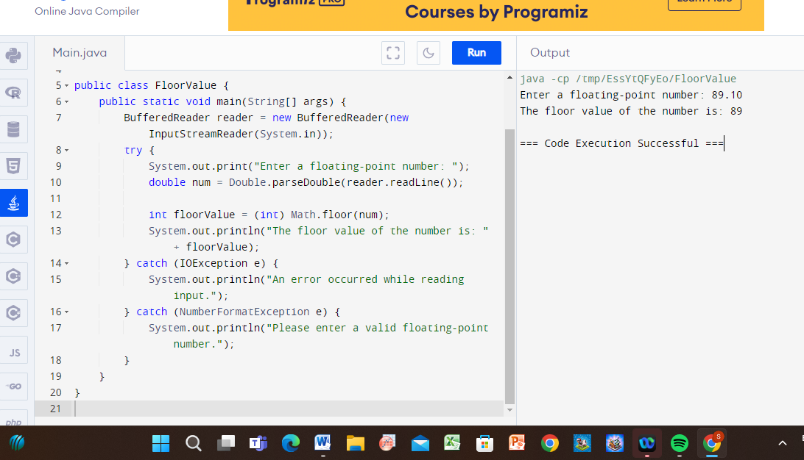

1. **RUN TIME PROGRAM FLOOR BY BUFFER READER IN JAVA:**

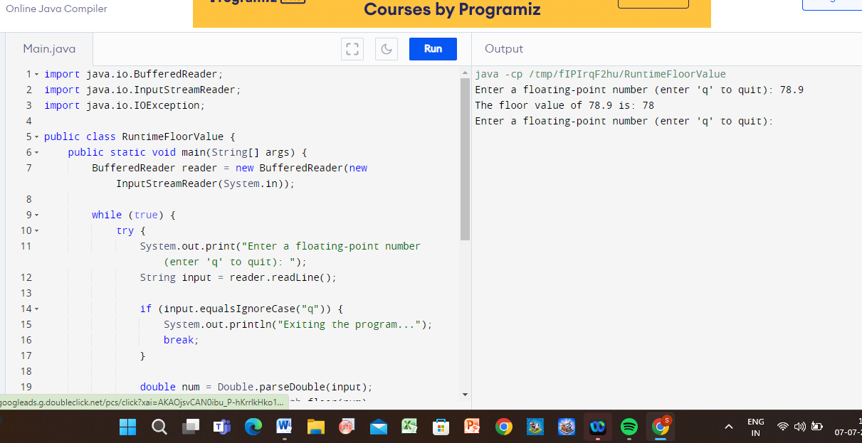

1. **RUN TIME PROGRAM FLOOR BY SCANNER IN JAVA :**

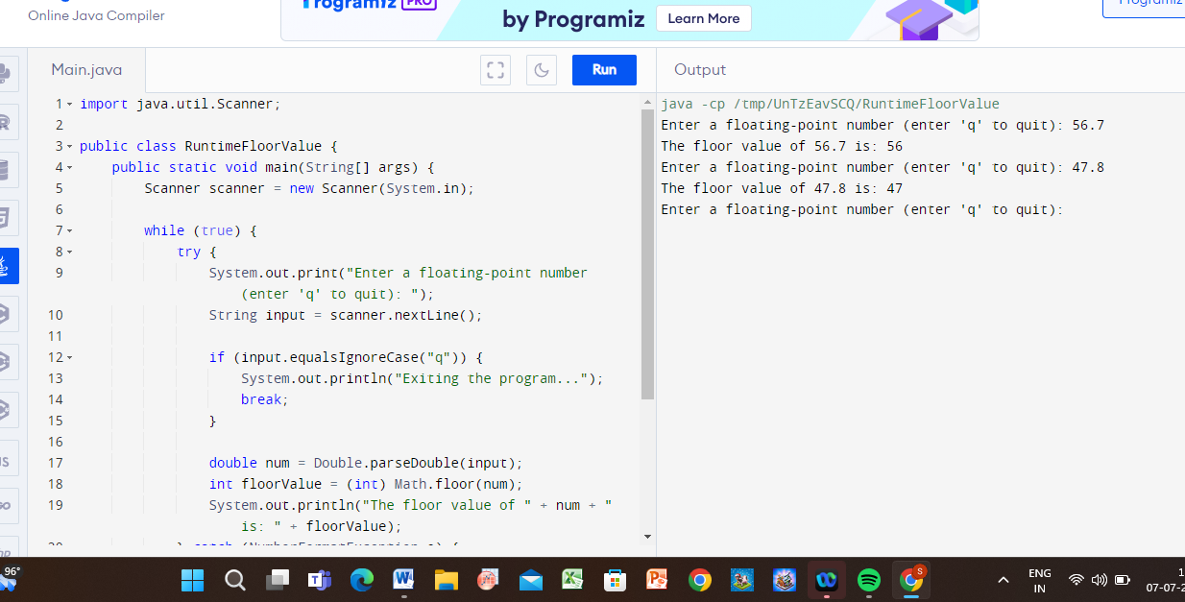

1. **COMPILE PROGRAM DOUBLE BY BUFFER IN JAVA:**

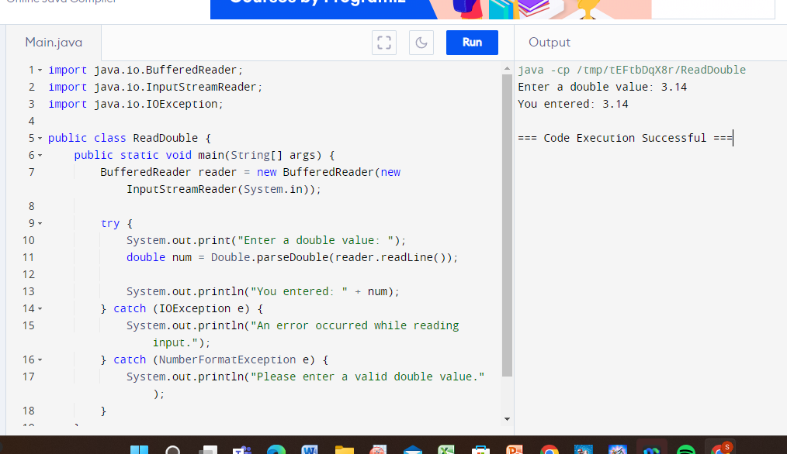

1. **RUN PROGRAM DOUBLE BY SCANNER IN JAVA:**

